|  |
| --- |
| E-Gram Seva |
| User Manual v2.0 |
| Team 22 April 8, 2013 |

|  |
| --- |
|  |

**REVISION HISTORY**

|  |  |  |
| --- | --- | --- |
| **Version** | **Author** | **Date** |
| Version 1 | Biman Gujral, Aayushi Sharma | February 16, 2013 |
| Version 1 Review | Abhishek Shukla | February 17, 2013 |
| Version 2 | Biman Gujral, Aayushi Sharma | March 31, 2013 |
| Version 2 Review | Krishna Mahajan | April 8, 2013 |

**CONTENTS**

1. **Introduction……………………………………………………………………………….….4**

1.1 Purpose of Document…………………………………………………………………..4

1.2 Motivation…………………………………………………………………..…………….4

1.3 Scope……………………………………………………………………………………..4

1. **Identification………………………………………………………………………………....4**

2.1 Application Overview…………………………………………………….……………...5

2.2 Project Environment …………………………………………………………………….5

2.3 Document Overview……………………………………………………………………..5

1. **System Requirements………………………………………………………………………5**

3.1 User-side Requirements…………………………………………………………………6

3.2 Developer-side Requirements…………………………………………………………..6

1. **Using the Software…………………………………………………………………………..6**

4.1 Home Page…………………………………………………………………………...……6

4.2 Registration…………………………………………………………………………...……6

4.3 User’s profile……………………………………………………………………………….7

4.4 Client’s profile……………………………………………………………………………...7

4.5 Categories of Information………………………………………………………………...7

4.6 Change Language…………………………………………………………………………8

4.7 Change/Forgot Password…………………………………………………………………8

4.8 About Us………………………………………………………………………………….…8

4.9 FAQs………………………………………………………………………………………...8

4.10 Contact Us…………………………………………………………………………………8

1. **Data Input Precautions………..……………………………………………………………..9**
2. **Frequently Asked Questions…………………………………………………....................9**
3. **Screen Shots of the Website………………………………………………………………..10**

7.1 Home Page………………………………………………………………………………...11

7.2 About Us Page……………………………………………………………………………..11

7.2 FAQs Page…………………………………………………………………………………12

7.3 Register Page(Sign Up)…………………………………………………………………..12

7.4 Login Page…………………………………………………………………………………13

7.5 User Account (after login)…..…………………………………………………………….13

7.6 Prices of Crops Page………………………………………………………….…………..14

* 1. Weather Information Page…………………………………………………..…….……...14

7.8 Health Care Page………………………………………………………………………….15

7.9 Change Password Page…………………………………………………………………..15

7.9 User Account (edit subscriptions)……………………………………………………….16

7.10 Admin Account (View Users Registered)………………………………………………16

**1. Introduction**

Our application makes agriculture related news like prices of grains and weather forecast and health-care updates easily available to the villagers (end users) specifically in the form of SMS updates on their mobiles. A website, test-implemented for the client NGO, will let subscribers know about soils, seeds etc. in more detail. The format of the website has the homepage that shows NGO’s information and gives options for the user to register and login to access that information . In this way it serves as cheap and effective way of providing information.

**1.1 Purpose**

The user manual helps the users (end users and the client(admin)) to understand the functionalities of the product. All the features of the software are explained in this document. This will enable the user to easily understand the working and use the software in an efficient manner.

**1.2 Motivation**

Researchers have long been interested in the potential of ICTs to bring about development in rural India. In these environments, ICT interventions often fail because political, social and cultural forces work against the changes ICTs entail. We focus on India's rural region where villagers face challenges due to resistance to change in the village, and because of their limited education, training and knowledge. As a consequence, villagers are often deprived of latest information relevant to their businesses. These factors appear to reduce the motivation of their development and impair their performance in their respective occupation.  
Our software is mainly intended to reach the mass of rural population who are not able to access useful information on the internet. It is handy for them to obtain related and concerning information in their regional language through mobile phones, which is now a common thing amongst the rural mass.

**1.3 Scope**  
The software provides the villagers to obtain information pertinent to their requirements such as latest prices of agricultural products, health care bulletins etc. on a regular basis. The user will be enabled to subscribe to various categories such as farming, jobs, healthcare, education etc. and will be frequently updated with latest information in these fields through SMS service.

**2. Identification**

This document is made in reference to the E-Gram Seva project made by Team 22 as a part of our course structure for IT314, Software Engineering under Prof. Asim Banerjee. This document helps in providing the client and the users comprehensive details about using the software so that they benefit from it maximally.   
  
**2.1 Application Overview**

The software enables the end-users to obtain SMS updates of information relevant to them such as prices of grains, health-care support and weather forecast. A website will help the users to maintain an account and get detailed information about crop prices.

**2.2 Project environment**  
  
Since all mobile OS supports basic SMS services, this software is mobile platform independent. The website has been developed in Windows environment.

**2.3 Document Overview**As stated earlier this document helps in providing the client comprehensive details about using the software so that they benefit from it maximally. The document explains the format of the message sent by end user for registration. It also explains the functionalities of all tabs, buttons and menu options available to the users of the website.

**3. System Requirements**

The end user can access the service using a simple handset without requiring any latest platform supporting internet connection.

**3.1 User Side Requirements**

* Any mobile handset
* A Network SIM Card
* For the website, any device with good internet connection and a web browser

**3.2 Developer side Requirements**

* Hard Disk Support for storing database
* Virtual Web Ripper tool
* Operating System – Windows-XP/Vista/7/8

**4. Using the Software**

**4.1 Home Page**

This feature will enable any user or in general any person to get acquainted with this service. Details of registration process and functioning are given in this section. Menu options will be displayed in one part of the home page. They help navigate to other pages of the website (for instance, details of agricultural news, weather etc.). Also, information about the NGO which is providing the service (Yuva Unstoppable, our client) will be displayed.

**4.2 Registrations**

The users can register for the service using both mobile phone as well as on the website, if access if provided. Registration provides the user with his/her own personalized profile to access/modify service.  
Registration can be done in two ways:

* **Via SMS**

Users, to avail the services, will send a code. The code will be of a definite format and will be notified to the users through an SMS. The code is of the following format: “REG<space>1/2/3. Here, the numbers 1, 2 and 3 stand for the category of information, namely, prices, weather information and health respectively. In the response (verification) message, they are provided with an auto-generated numeric password for accessing their profiles on the website. The user can change it after first login. The username for the website is their mobile phone number itself.

* **Via website**

Login window feature available on the website provide login for registered user. The users which are not registered already can sign up on the website. The user are supposed to use their mobile phone number as their username for signup. They can enter a password of their choice which should only contain numeric.  
It contains following menus:

1. User Id
2. Password
3. Confirm Password (only for sign up)
4. Login/Signup
5. Categories of updates to be sent to mobile phone

When a user is registered his/her mobile phone number is subscribed to the updates of this service.

**4.3 User’s Profile**

When the user logs in, he/she can see the news details under various categories. They can navigate from category to category using the menu options.   
They can also change the subscription category of the information sent on their mobile phones.

**4.4 Client’s profile (Admin)**

This feature will enable a client to get the statistics of the users registered. This will help the client to assess the trends, requirement, and the total efficiency of the software.   
  
This creates future possibilities of adding new categories of information to the service. Thus, the service can be augmented in terms of information delivered.

**4.5 Information Categories**

The website has menu options to display useful information of various types. These comprise: prices of grains, weather information,& health care,. Displaying such information on the website will help the people who can access the website in addition to using the SMS updates.

**4.6 Change/Forgot Password**

If the user forgets the password, he/she can click on “Forgot Password?” option. This will display a page with a text field for mobile number User is sent his/her new password on this number.  
In case, after logging in, the user desires to change his/her password, he/she can use the “Change Password” option. You need to specify your old and new passwords on this page.

**4.8 About Us**

This will contain the details of the associated client. Our client is an NGO, Yuva Unstoppable, which will be delivering the service to the users. It will throw light on the activities of the NGO and their goals. It will also have a brief about this SMS service and how it aims to help the rural population.

**4.9 FAQs**

This feature enables user to get acquainted with some general questions (frequently asked) and answers related to the application. These questions are common and hence might be the query of many people. He/she will get a quick solution. FAQs that will be displayed on the website are listed at the end of this document.

**4.10 Contact Us**

This page displays information required to contact the client providing the service. You can find the name of the contact person/organization, telephone number, email-id and link to the client’s website.

**5. Data Input Precautions**

* The format of the message sent by the end user for registration should strictly be in the format notified. It should be:   
  **REG<space>1<space>/<space>2/<space>3**

` where the numbers 1, 2 and 3 stand for the category of information, i.e. prices, weather information and health respectively.

In case of registrations under multiple categories, the codes (1, 2, 3) should be separated by a space. In the future, when new categories will be added, they will also be assigned such numeric codes.

* If a user registers multiple times, then the old registration is overwritten. Now, only the categories listed in the new REG message will be considered as final for sending SMS updates. Though it is a precaution, it can be used by the user to change his subscription using his mobile phone.
* While signing up on the website, the user should take care to enter his mobile phone number as the username. Now, the service will be activated and the SMS updates will be sent on that number.
* The password entered should be comprised of only numeric and special characters.

**6. Frequently Asked Questions**

Q. How do I register?  
A. Send an SMS from your mobile. The format is “REG<space>1/2/3 where 1, 2 and 3 are categories of information for prices, weather and health care respectively. You can also signup on the website by clicking on signup and following the instructions that follow.

Q. How do I change my password?  
A. To change password, after logging into your account, go to the menu option “Change Password” in the top right corner of the page. You will be directed to the page where you can enter the old and new password in the respective fields.

Q. What to do if I forget my password?  
A. Go to the menu option “Forgot Password?”, you will be directed to a page where you will have to enter your mobile number. Click on “Okay”. The new password will be sent on that number.  
  
Q. How do I subscribe for new categories?  
A. Follow the same message format as for registering for the first time. Mention all the categories you want to subscribe to in this REG message.

Q. What is the maximum and minimum size of password I can add?

A. The minimum size is 6 characters and maximum size is 15 characters. You can use only numeric and special characters in the password.

**7. Screen Shots of the website**

7.1 Home Page

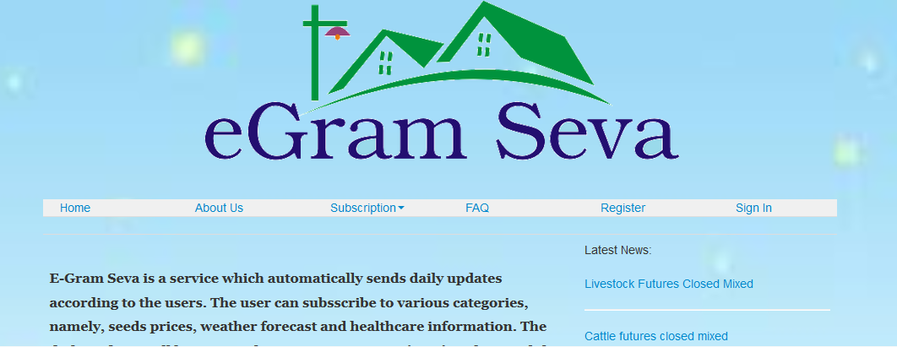

7.2 About Us Page

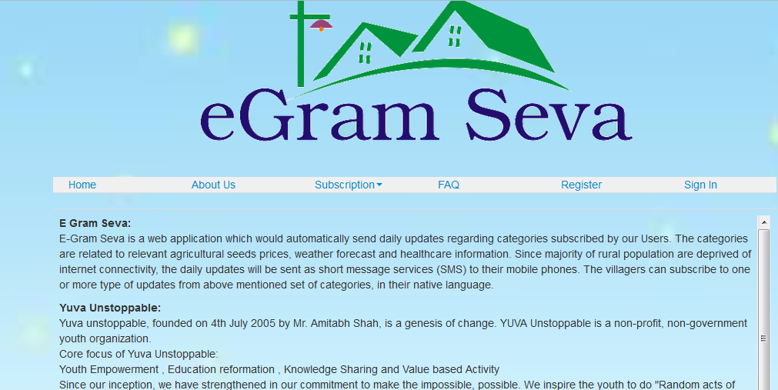

7.3 FAQs Page

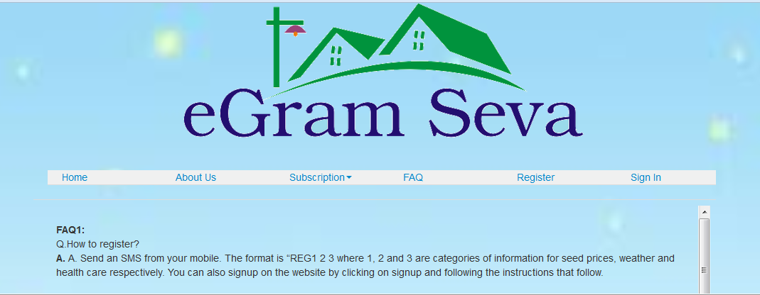

7.4 Register Page (Sign Up)

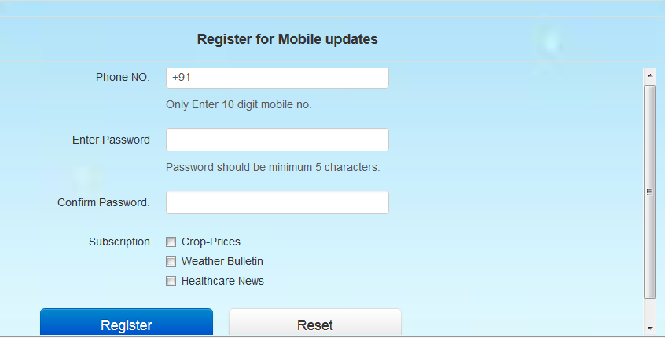

7.5 Login Page

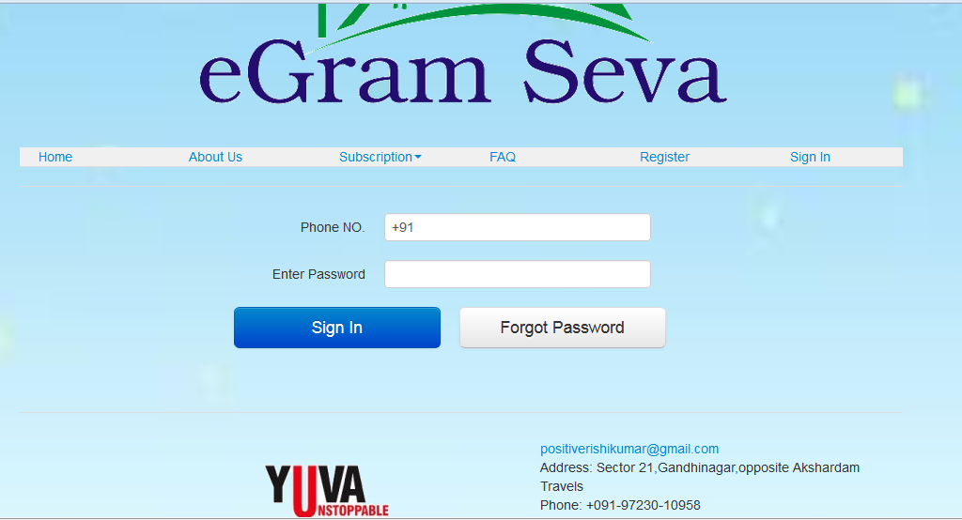

7.6 User Account (After Login)

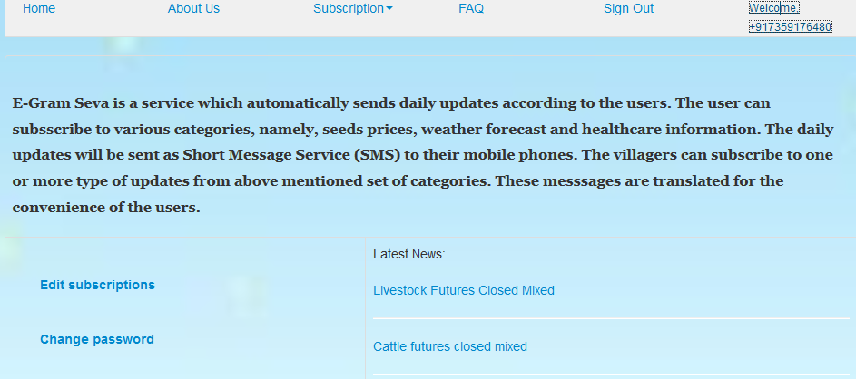

7.7 Prices of Crops Page

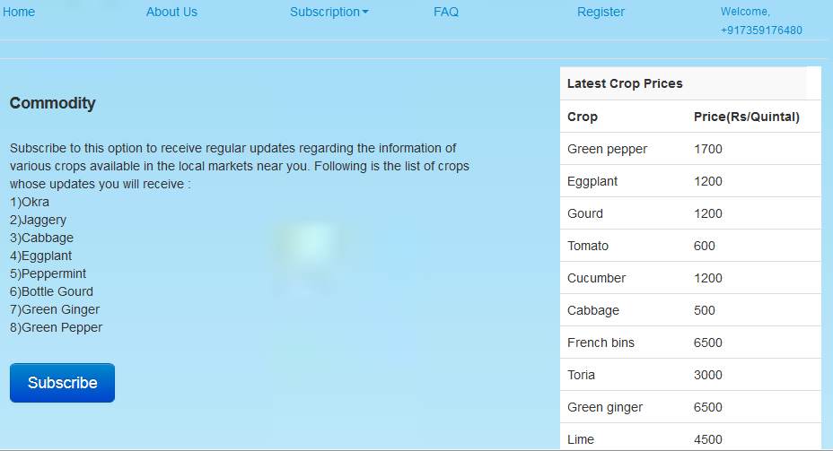

* 1. Weather Information Page

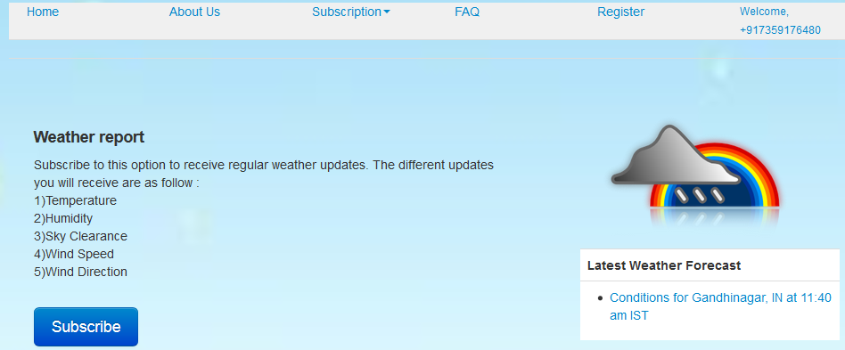

* 1. Health Care Page

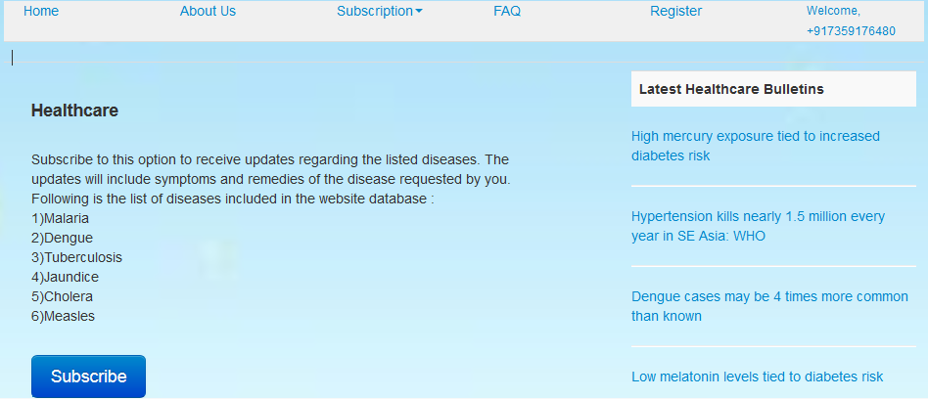

* 1. Change Password Page

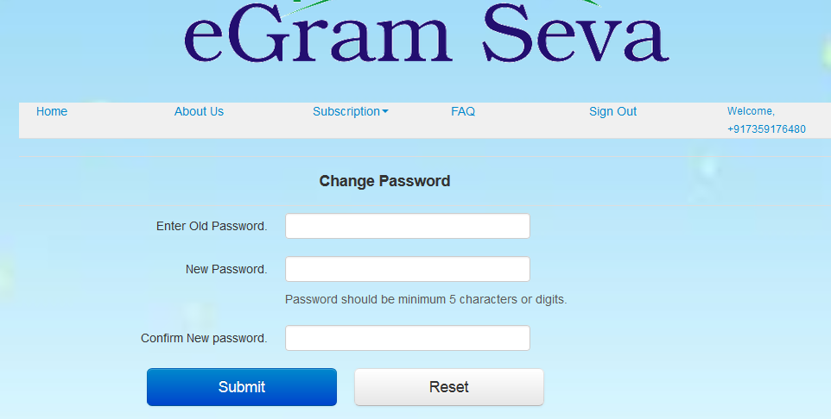

* 1. User Account(edit subscriptions)

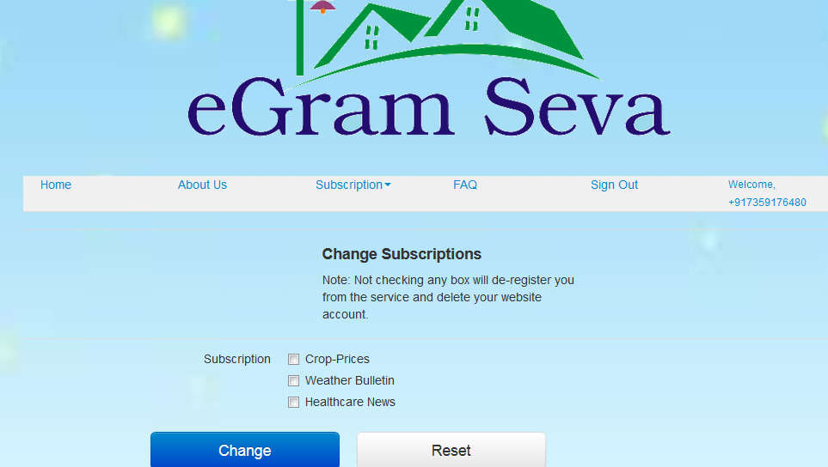

* 1. Admin Account (View Users Registered)

